Finite Element Analysis of Deep Beam

Input data

|  |  |
| --- | --- |
| Length - m, Height - m  Thickness - m  Distributed load - kN/m  **Loads**  Load length - m  Load position - m  Load function - |  |

**Supports**

Support length - m

Support elastic stiffness - MN/m²

Support function -

**Material properties**

Modulus of elasticity - MPa

Poisson`s ratio -

Finite element mesh

We will use rectangular finite element with DOFs

Number of elements along *l* and *h* - ,

Total number of elements -

Total number of joints -

Element dimensions - ,

Joint coordinates

m

m

Joint numbers for elements

Coordinates of element centers

,

m

m

Elements along the bottom (supported) edge

Elements along the top (loaded) edge



Finite element formation

**Shape functions**

They are defined in relative coordinates to the center of the element:

⚓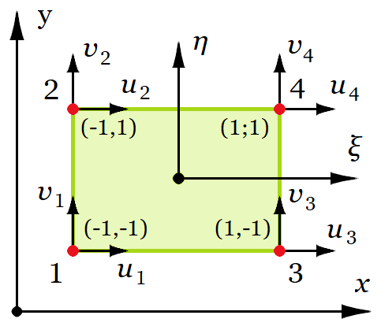

∈ (-1; 1), ∈ (-1; 1)

Base functions - ,

First derivatives - ,

Shape functions for joints at elements` corners

,

,

**Constitutive matrix** (stress-strain relationship)

**Strain-displacement matrix**

The elements of the stiffness matrix will be calculated by using direct integration

**Element stiffness matrix** (above the main diagonal only)

MN/m

Boundary conditions

Supports

Number of elements along the supported edge -

Element′s joint springs stiffness factors

, ,

Results for element 1

, MN/m

, MN/m

Number of elements along the loaded edge -

Element load vector

, ,

Results for element 100

, kN

, kN

Solution

Global stiffness matrix

Global load vector

kN

Solution of the system of equations

mm

Results

Horizontal joint displacements, ·10-3mm

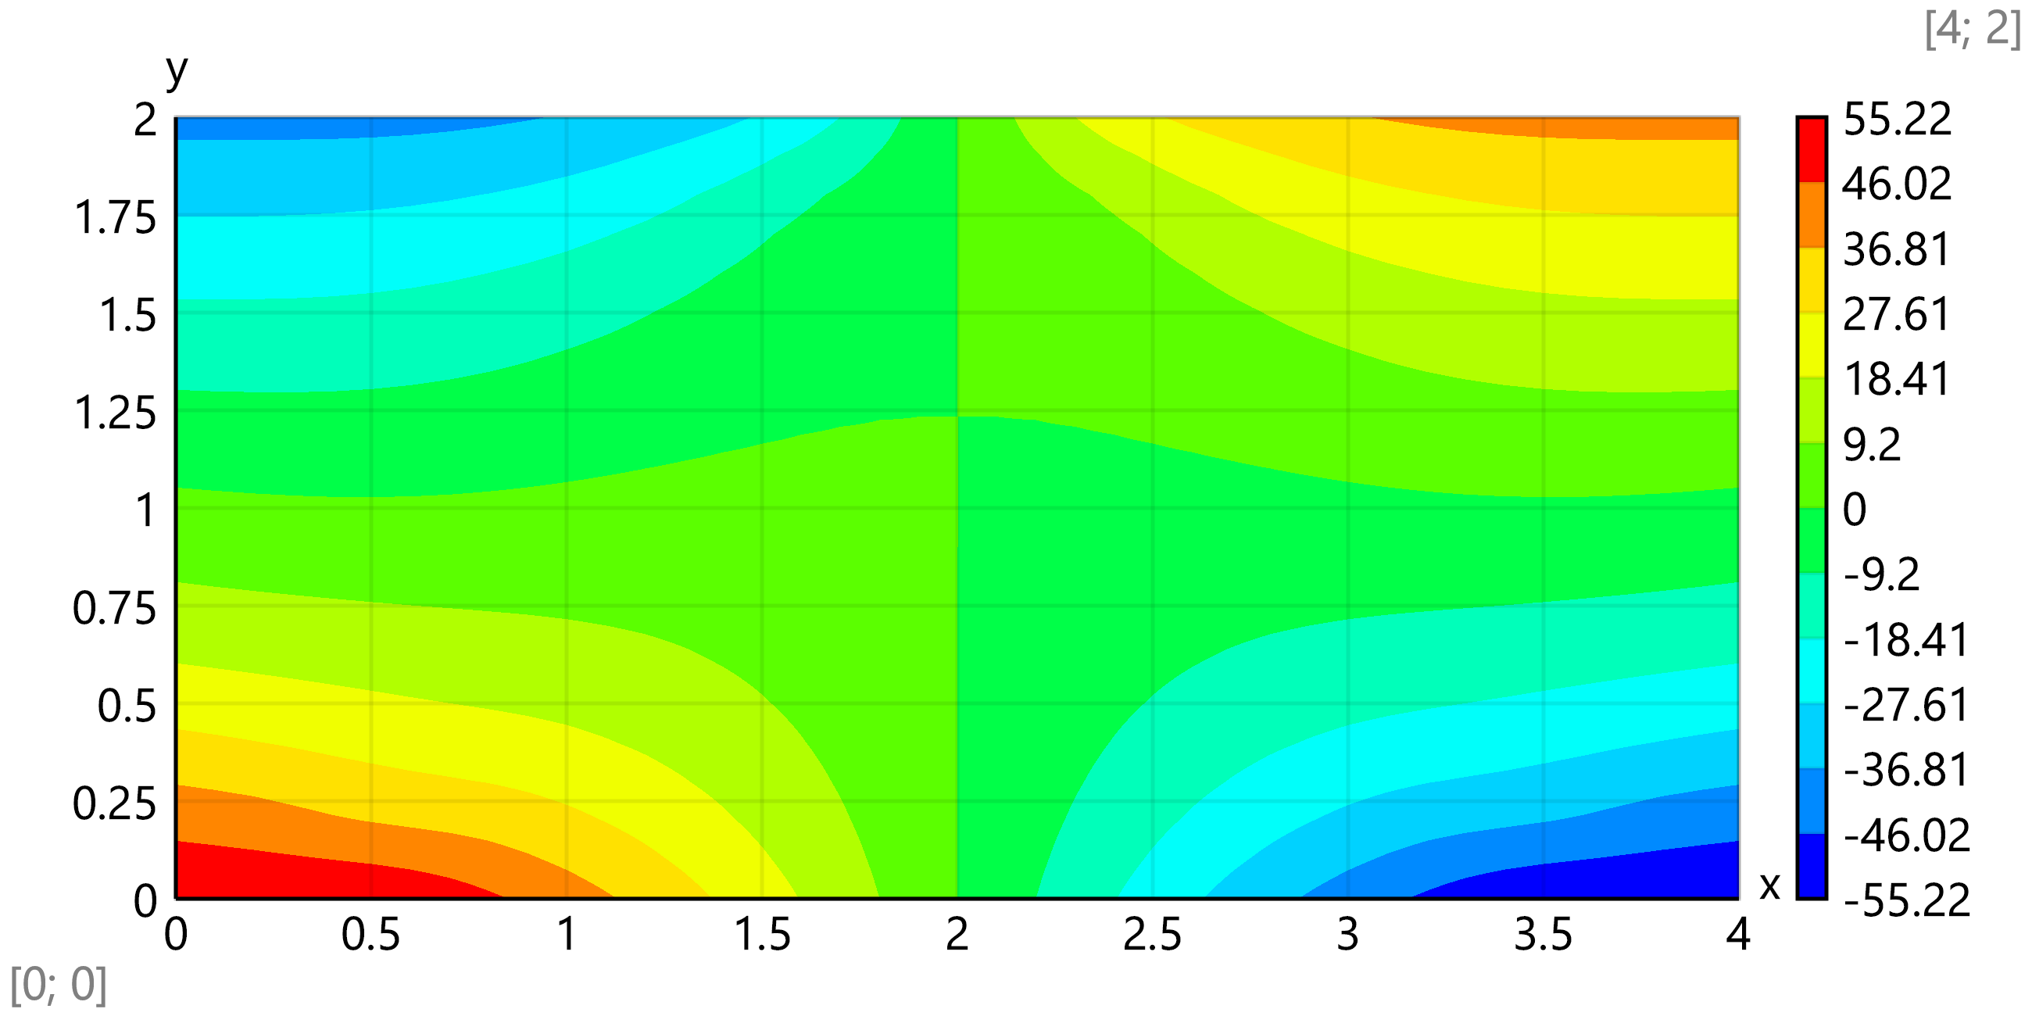

Vertical joint displacements, ·10-3mm

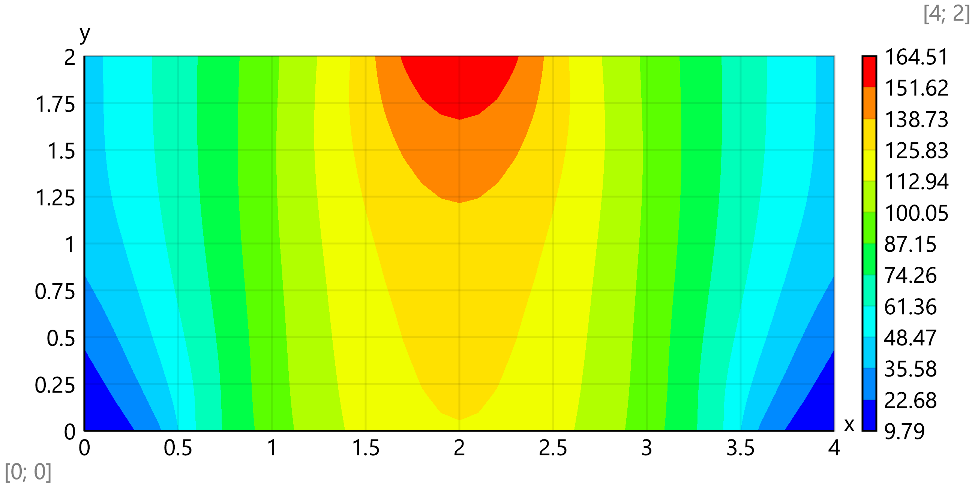

Calculation of internal forces

Displacements for joint -

Displacements for element -

Membrane forces in element -

Results for element 101 and joint 111:

mm

kN/m

Average membrane forces at joints, kN/m

Membrane forces for the structure

Normal membrane forces - *N*x, kN/m

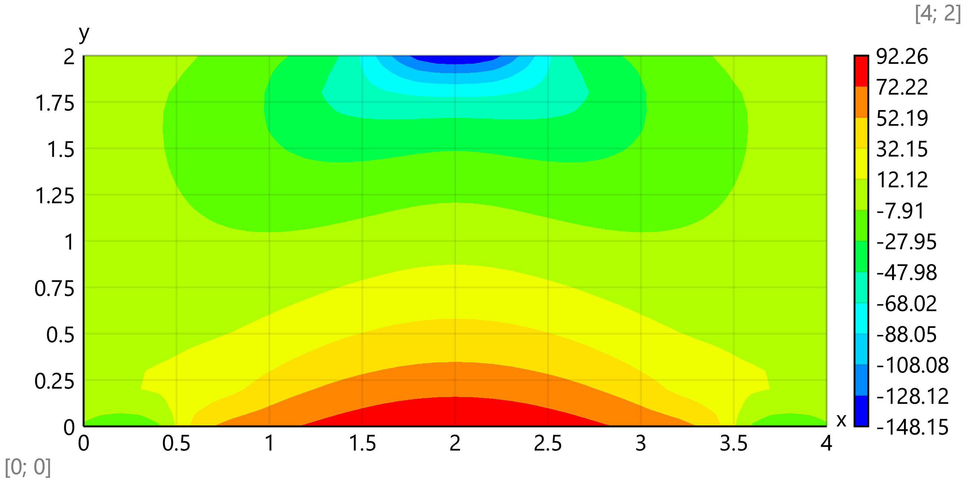

Plot for *N*x, kN/m at *x* = *l*/2

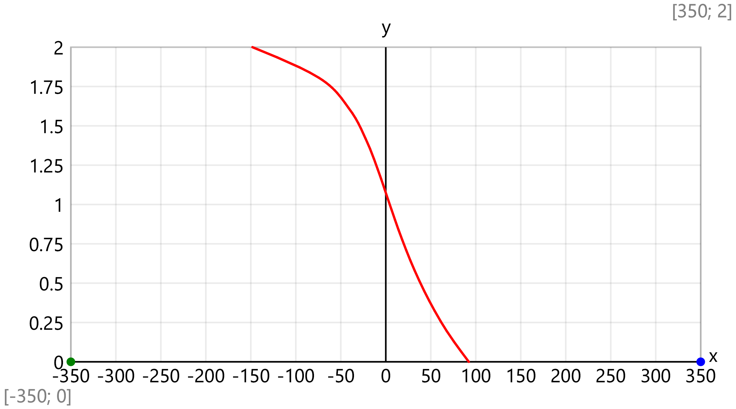

Bottom value - kN/m

Top value - kN/m

Normal membrane forces - *N*y, kN/m

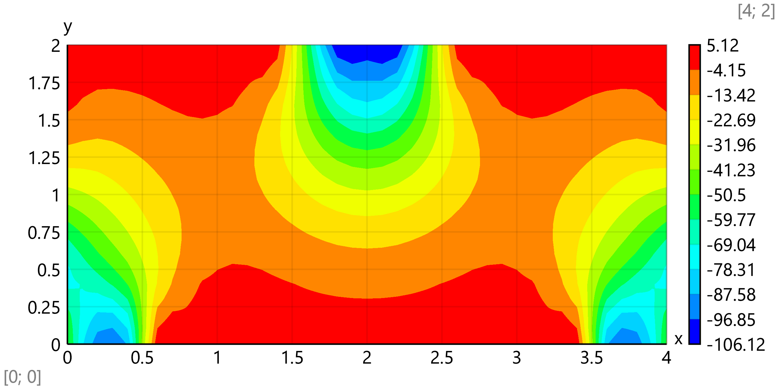

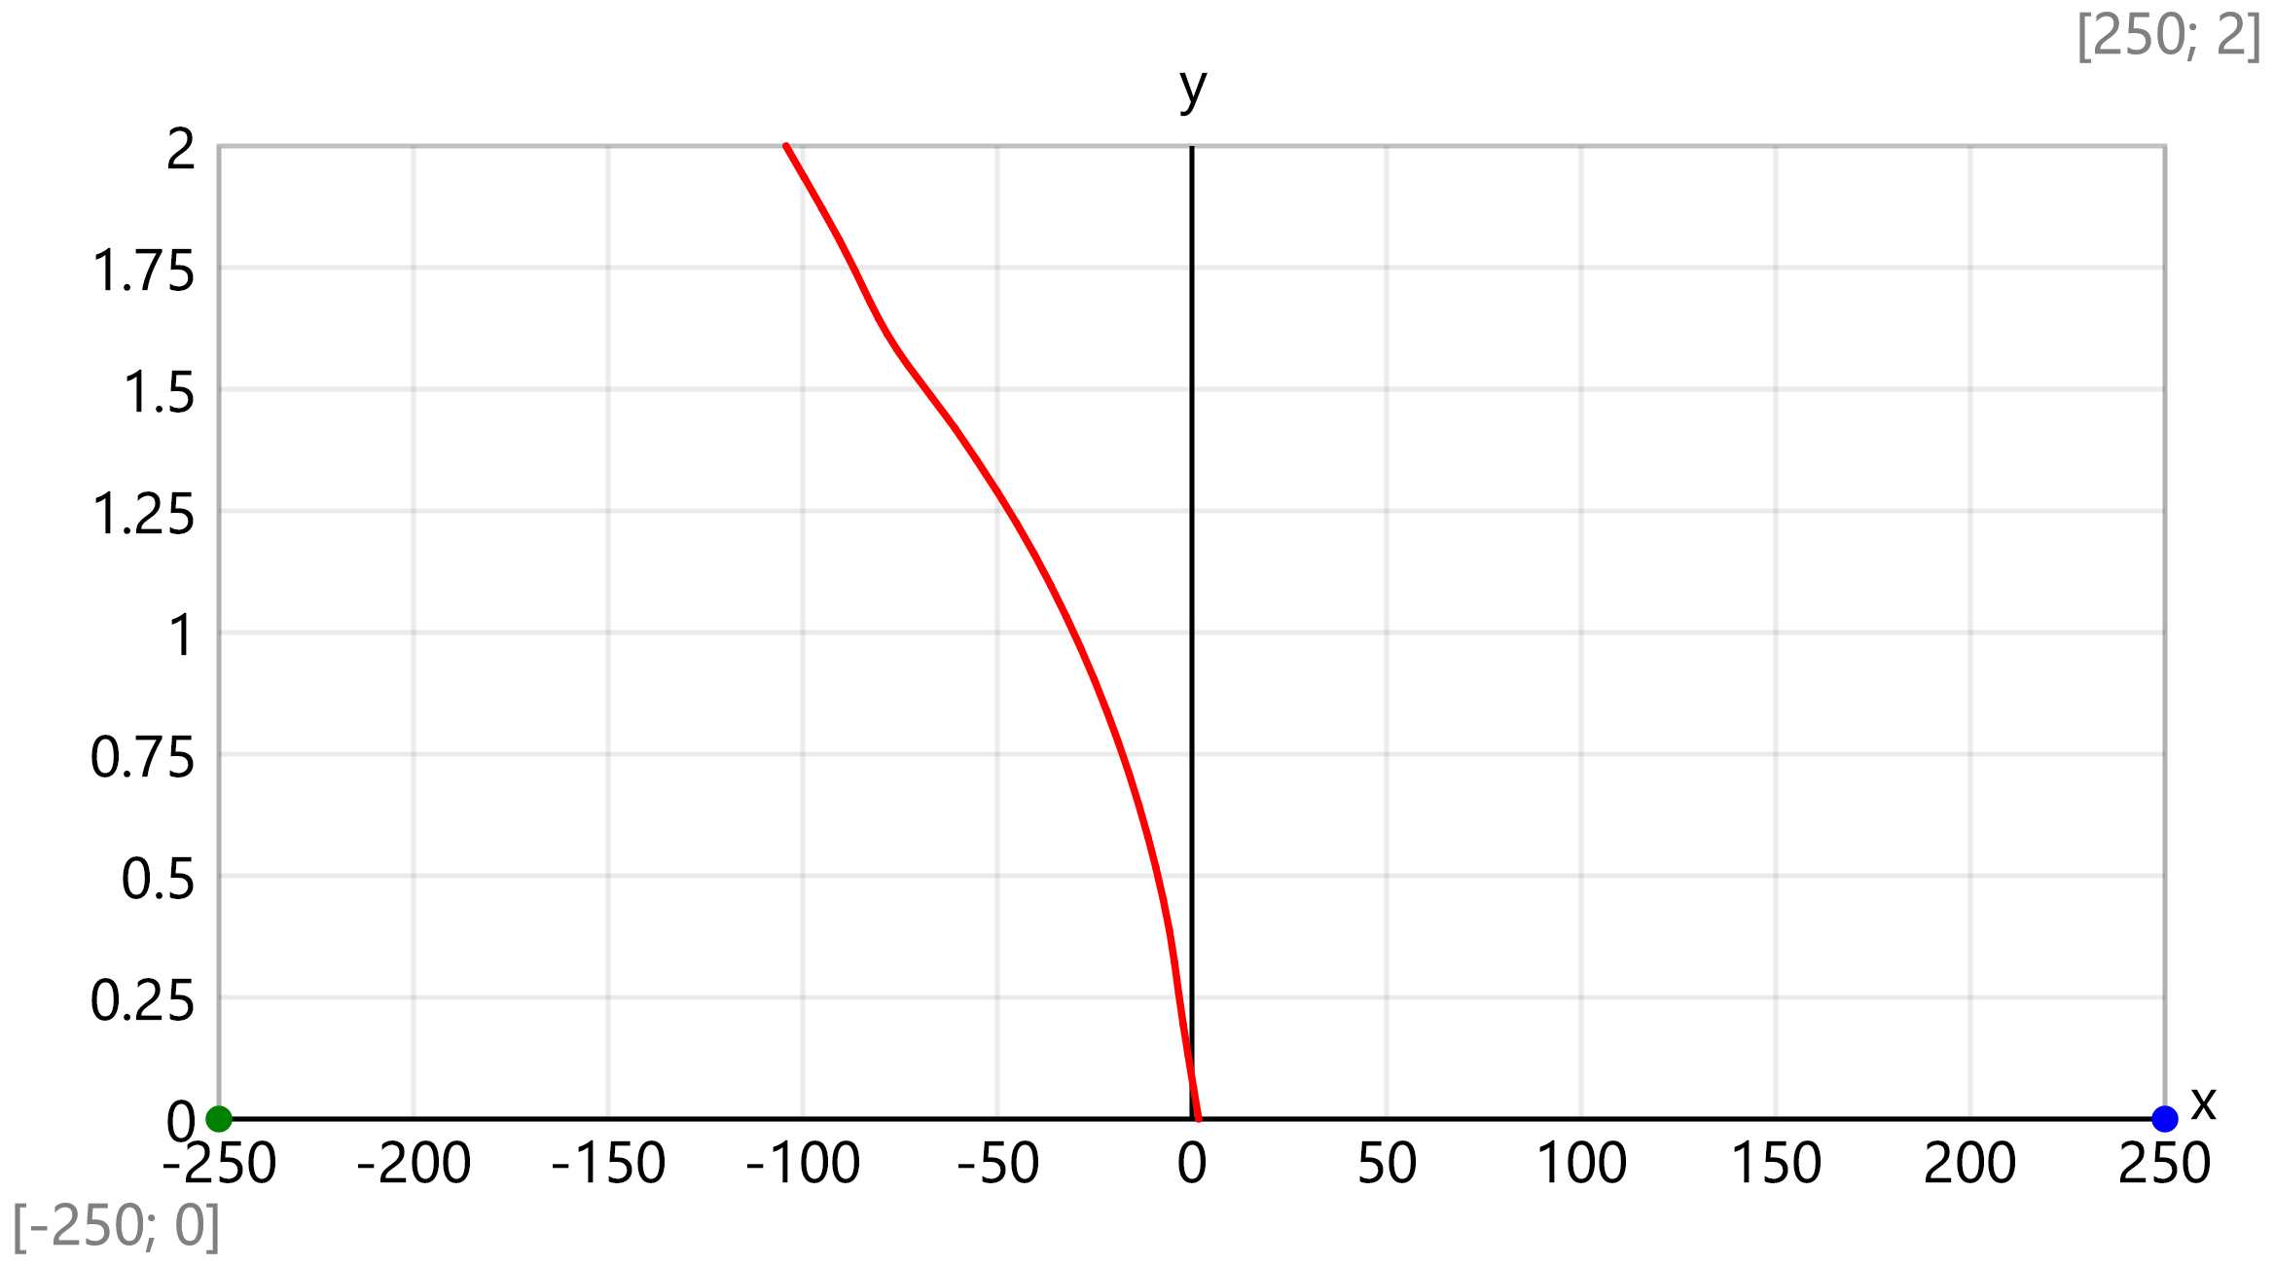

Top value - kN/m

Shear membrane forces - *N*xy, kN/m

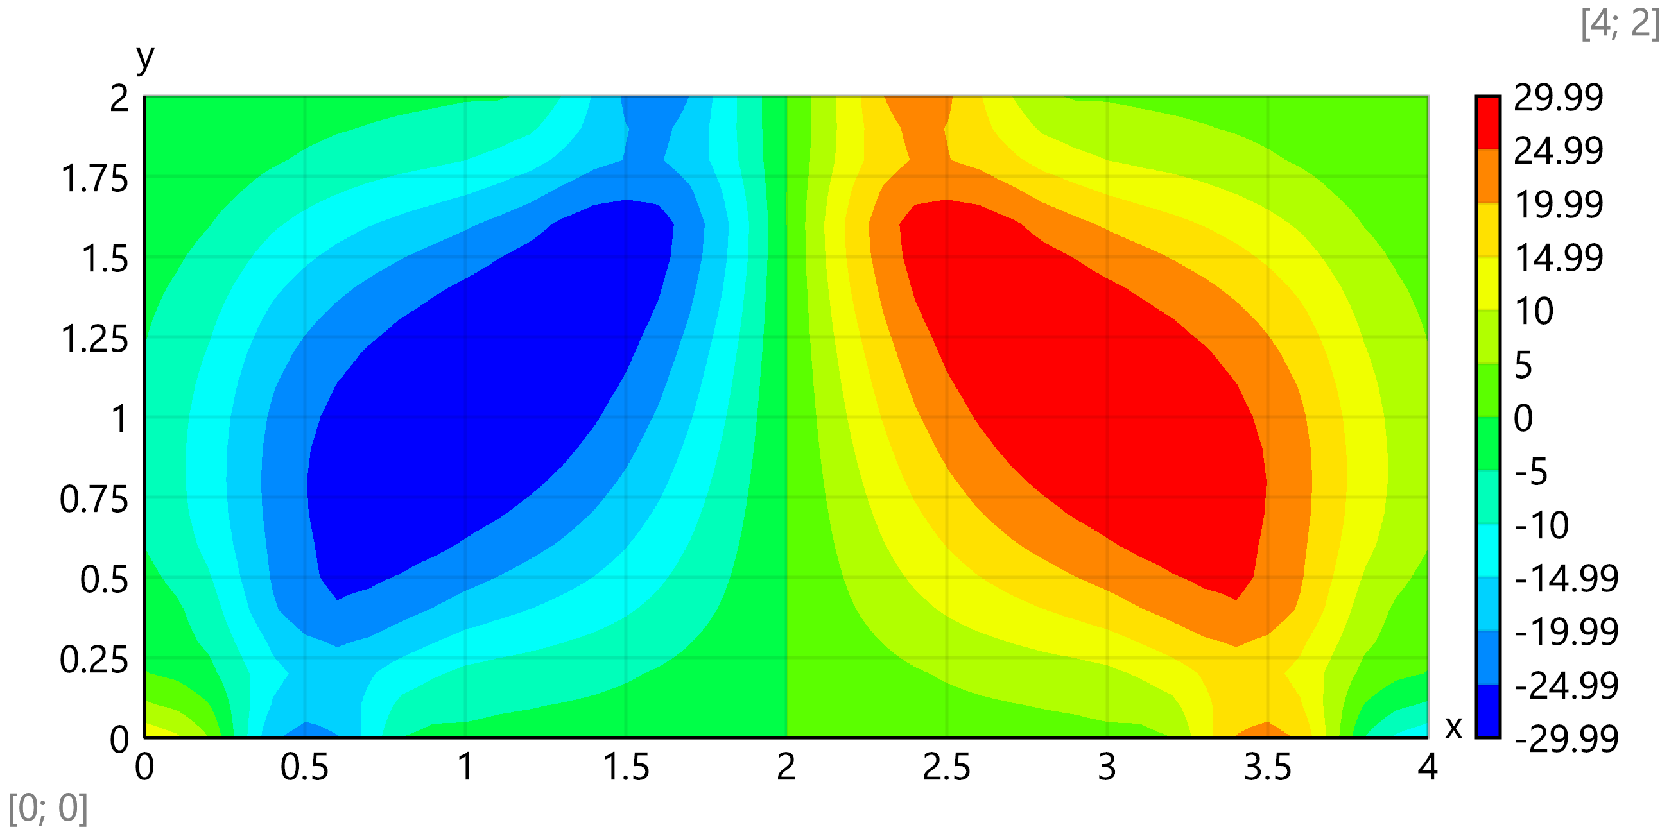

Max. value at 3/4 of span - kN/m

Principal membrane forces, kN/m

kN/m

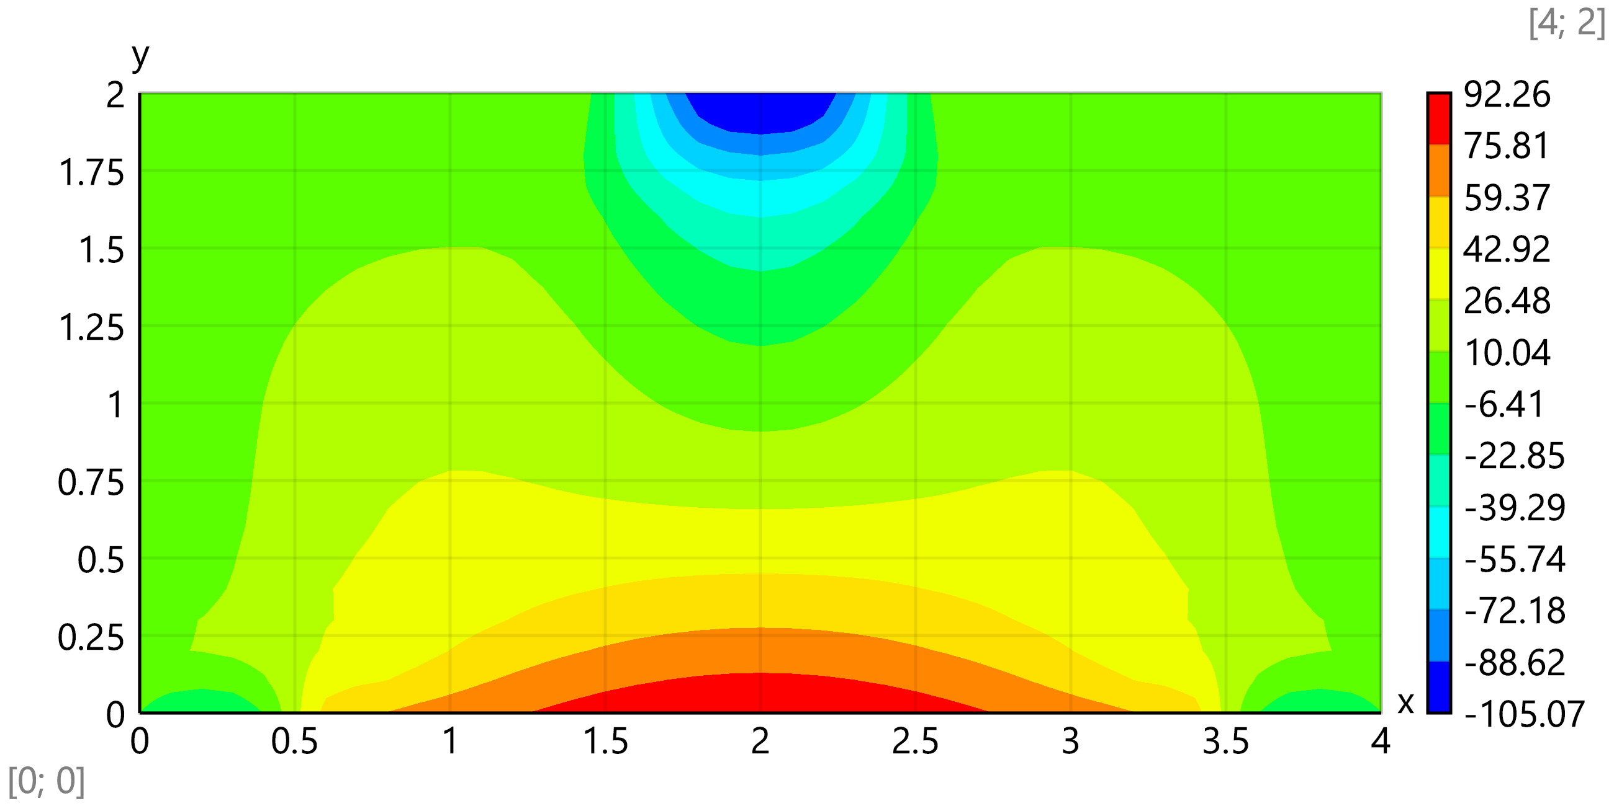

kN/m

